Ecommerce Analysis Report

1 Relationships between actual price and selling price

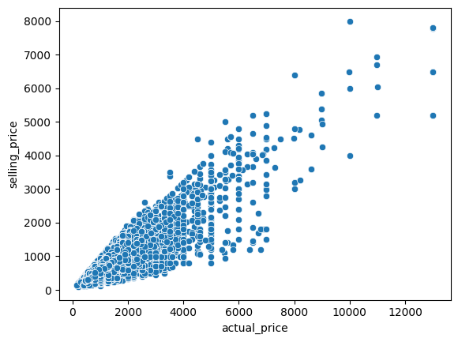

The scatter plot analyzing the relationship between selling price and actual price reveals a positive correlation, indicating a general tendency for products with higher actual prices to also have higher selling prices.

2 Relation Category vs actual price

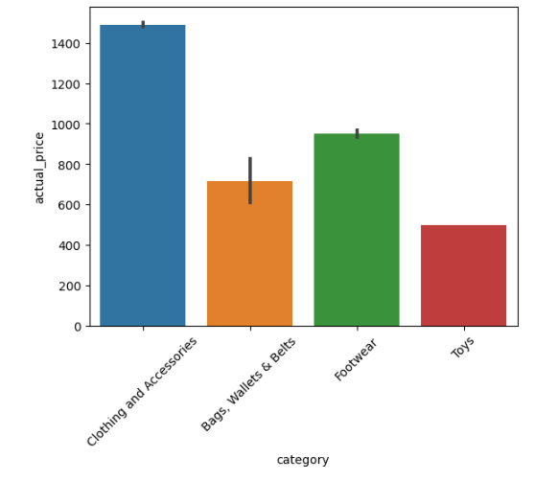

This analysis reveals a clear hierarchy in average pricing across the four categories. Clothing and accessories lead the pack with an average actual price of 1,400, followed by bags and belts at an average of 650. Footwear falls within the middle range at an average of 850, and toys are the most affordable category with an average of 450.

3 Visualize relationships between multiple numeric variables using pair plots

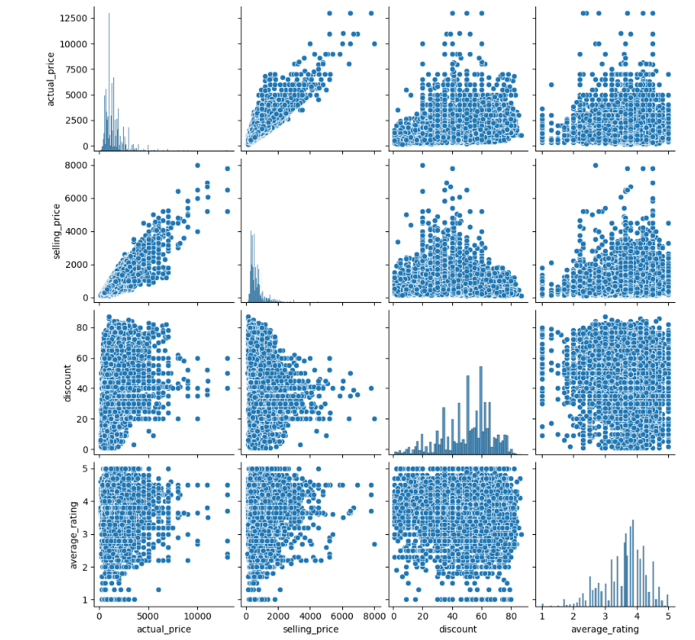

Discounting Strategy: Products with higher actual prices tend to be discounted more heavily, typically falling within a range of 40% to 60%. This suggests a potential strategy where businesses leverage discounts to make higher-priced items more attractive to budget-conscious customers Correlation Between Price and Rating

The analysis indicates a possible correlation between selling price and average rating, with products having a selling price in the range of 3.5 to 4.5 stars on average. This could imply that customers might associate higher prices with better quality or brand value, leading to slightly higher average ratings.

4 Relation between category vs out of stock Analysis

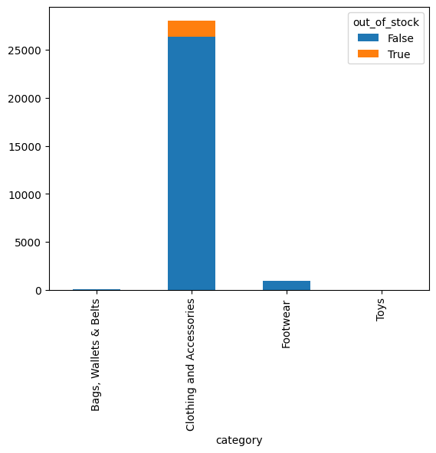

The bar graph reveals that out-of-stock inventory levels are highest for footwear, followed by clothing and accessories. Conversely, toys and bags, wallets, and belts have relatively lower out-of-stock levels. This information can inform several aspects of your business operations. For instance, you might

Prioritize restocking efforts for categories with the most significant out-of-stock issues, such as footwear in this case.

5 Distribution of brand based on the distribution 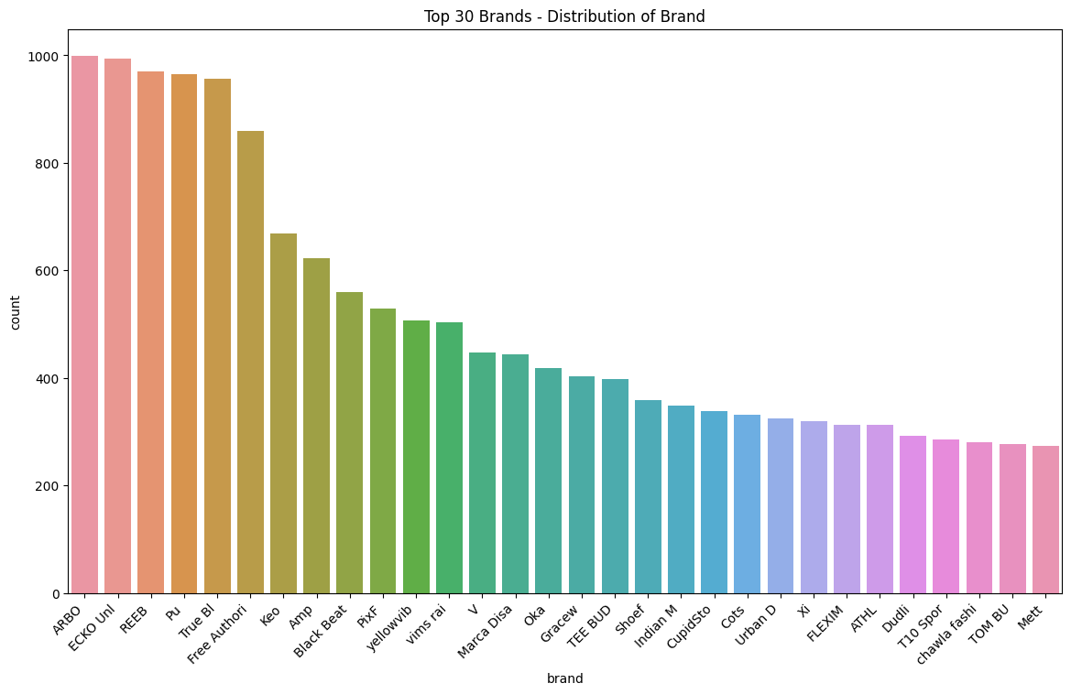

6 Top 10 sellers based on number of products

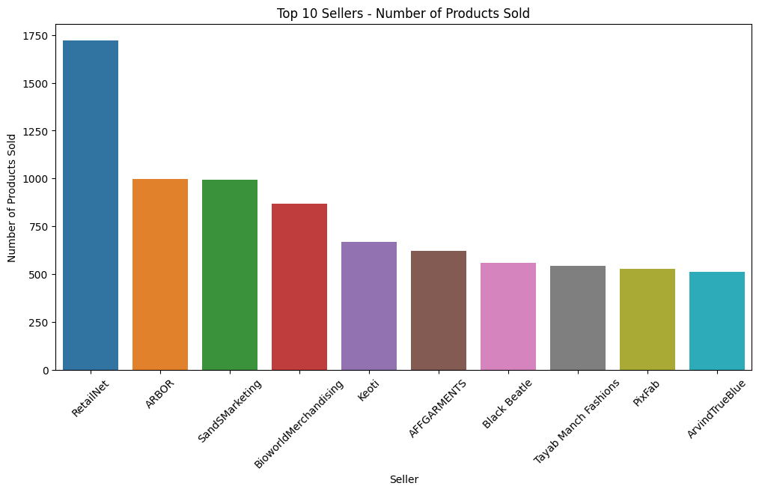

The bar graph you described reveals that RetailNet has the highest number of products, followed by ARBOR and SandSMarketing. The remaining companies on the list appear to have progressively fewer products.

7 Discount vs selling price top seller

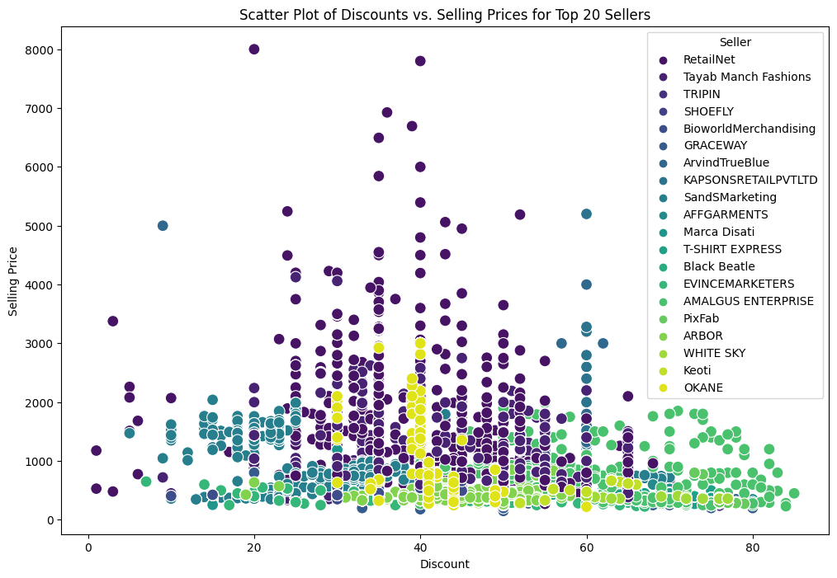

The scatter plot analyzing the relationship between discounts and selling prices for top sellers, reveals a positive correlation. This indicates a general tendency for products with higher selling prices to also have higher discounts.

8 Average rating by category

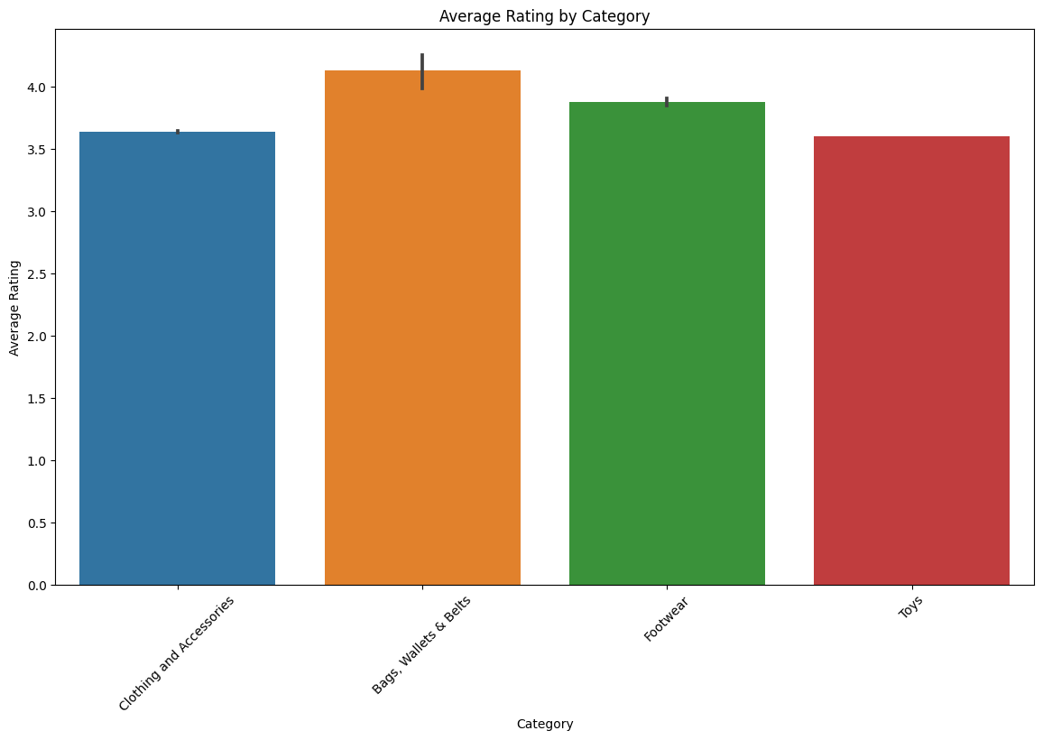

The bar graph reveals a positive correlation between average rating and customer satisfaction, indicating that products with higher average ratings tend to be associated with greater customer satisfaction.

9 Average rating top 25 Brand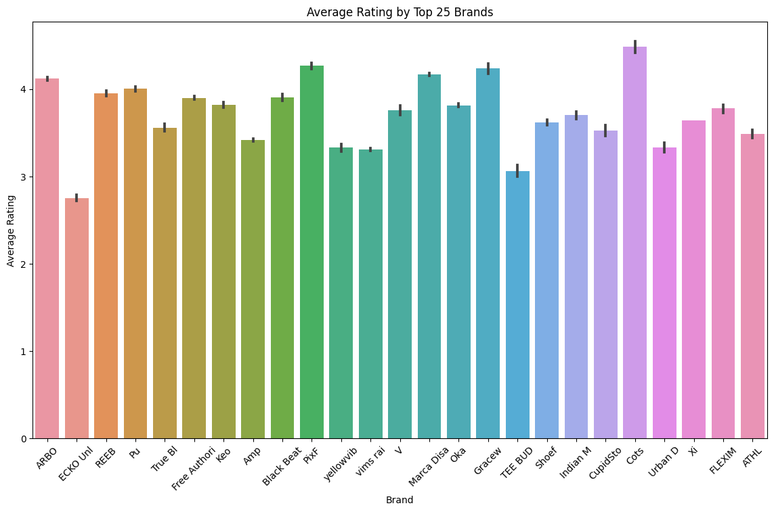

10 Word cloud of Processed Description

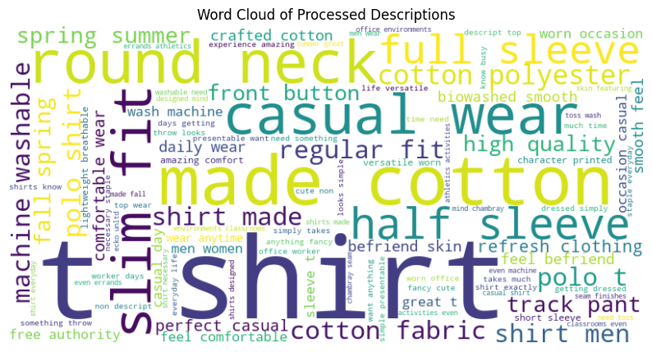

11 Discount percentage by category

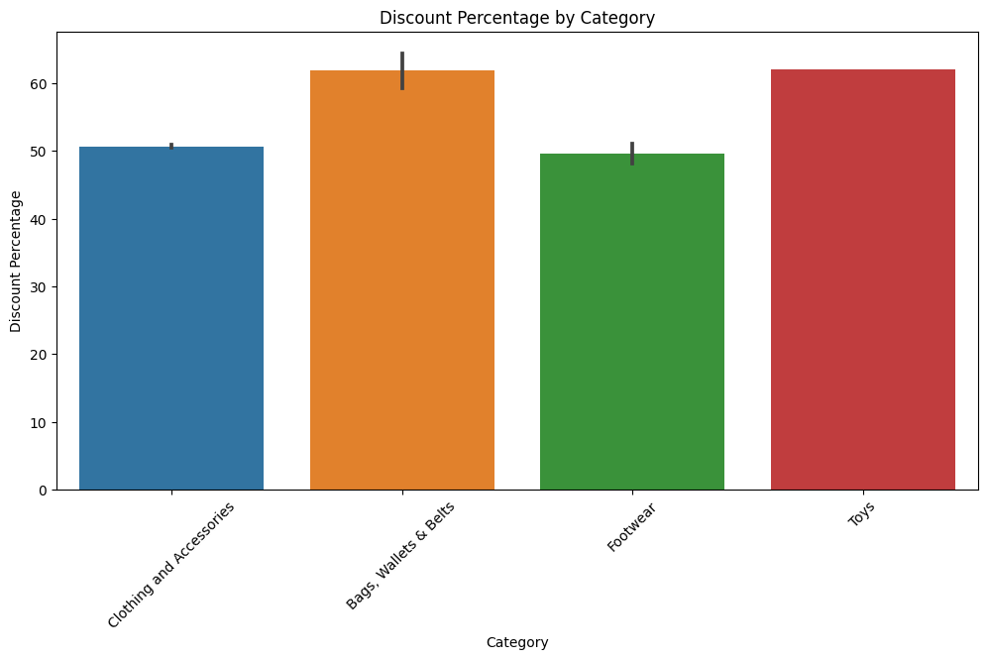

12 Discount percentage by top 20 brand

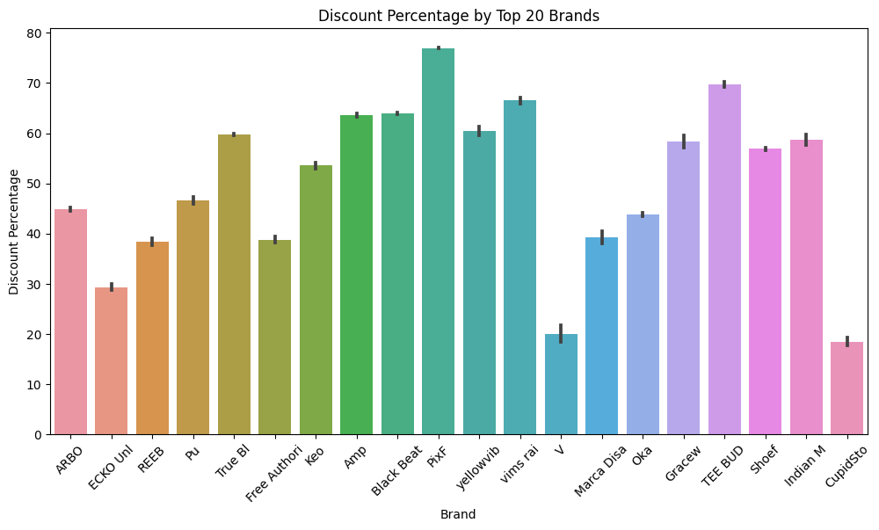

13 Average rating by top 20 seller

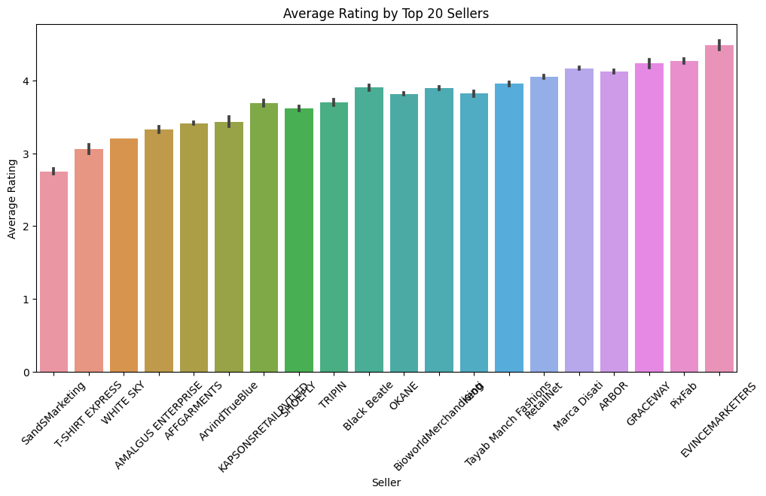

14 Top 20 brand by Highest average Discount

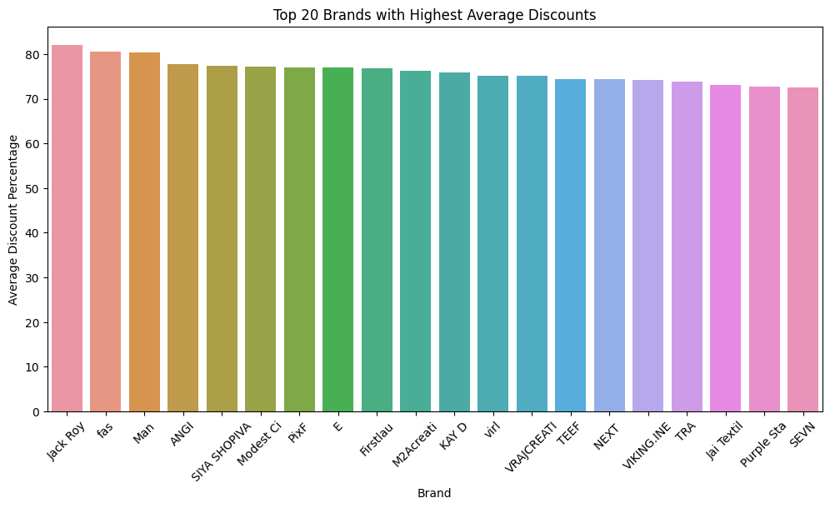

15 Top Rated Products:

title average_rating

419 Solid Men Red Chino Shorts 5.0

425 Printed Men Boxer  (Pack of 1) 5.0

451 Printed Men Boxer  (Pack of 1) 5.0

464 Printed Men Round Neck White T-Shirt 5.0

790 Men Kurta and Pyjama Set Cotton Blend 5.0

804 Men Kurta and Pyjama Set Cotton Blend 5.0

1204 Color Block Men Round Neck Multicolor T-Shirt 5.0

1977 Sleeveless Solid Men Casual Jacket 5.0

2065 Self Design Men Black Track Pants 5.0

2128 Solid Men Black Track Pants 5.0